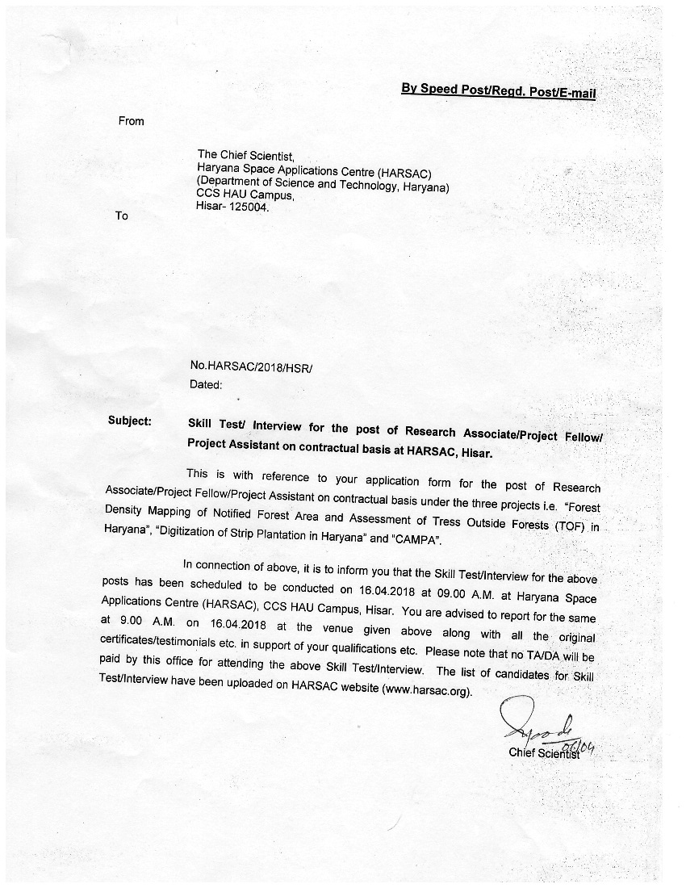

LIST OF CANDIDATES WHO FOR SKILL TEST/ INTERVIEW HELD ON 16.04.2018

POST: RESEARCH ASSOCIATE (01)

PROJECT: Forest Density Mapping of Notified Forest Area and Assessment of Trees Outside Forests in Haryana

Sr. No. | Name & Address
1. | Mr.Rupesh Kumar  S/o Sh.Shishpal  VPO. Pabra, Distt. Hisar  Email: rupesh.kumar176@gmail.com
2. | Mr.Vikas Sihag  S/o Sh.Krishan Kumar  H. No.612, Sector-6, Hansi.  Email: vks.sihag@gmail.com
3. | Ms.Ritu Sharma  D/o Sh.Om Parkash  H. No.1725B, Amardeep Colony, Kaimri Road, Hisar  Email: rituswastik@gmail.com

LIST OF CANDIDATES WHO FOR SKILL TEST/ INTERVIEW HELD ON 16.04.2018

POST: PROJECT FELLOW

PROJECT: Forest Density Mapping of Notified Forest Area and Assessment of Trees Outside Forests in Haryana

Sr. No. | Name & Address
1. | Mr. Parmod Kumar  S/o Mehar Singh  H.No. 860, Sector- 15A, Hisar  Email: parmodkalkal@gmail.com
2. | Mr. Kaptan Singh  S/o Sh. Jaswant Singh  H.No. 3212, Near SNP School, M. Adampur Distt. Hisar Haryana  Email: singhaniakaptan@gmail.com
3. | Mr.Sachin Kumar  S/o Sh.Raj Pal  # 248/19, Dr.Jai Singh Gali,  Nr. Dinanath School, Jind Road, Hanuman Nagar Narwana  Email:sachinkumar772222@gmail.com
4. | Mr. Sumit Kumar  S/o Sh. Suresh Kumar  #62, Nirmal Chhaya Apartment kitchlu Nagar,wdhiana, Panjab- 141004  Email: sachinkumarkuk@gmail.com
5. | Ms. Seema  D/o Sh. Raghubir Singh  H.No. 622, Street No. 11, Kundu Sadan,  Jhawar Nagar, Hisar, Haryana  Email: seemakunnu@gmail.com
6. | Mr.Anand Kumar  S/o Sh. A.S. Yadav  33/2A, Vasant Village, Near Hanuman Mandir, New Delhi  Email: nnd.ydv@gmail.com
7. | Ms. Kiran Gupta  D/o Sh.Hira Lal Gupta  B-1/278, Sector-G, Jankipuram, Near Icon Hospital- Lucknow- 226021  Email: ashakiekkiran@gmail.com
8. | Mr. Basant Rai  S/o Sh. Lt. Sh. Chiranji Lal  H.No. 881, Sector 15A, Hisar - 125001  Email: basantrai79@gmail.com
9. | Ms. Poonam Sharma  D/o Sh. Ram Phal Sharma  VPO. – Danoda Kalan, Teh. Narwana, Distt. Jind  Email: sheopranpoonam6@gmail.com
10. | Mr. Sattyam  S/o Sh. Raj Kumar Tripathi  AA-1, Education Board Campus, BSEH, Bhiwani, Haryana  Email: tripathisattyam@gmail.com

Sr. No. | Name & Address
11. | Mr. Manjit Singh  S/o Sh. Hawa Singh  VPO. – Ghirai, Teh. Hansi Distt. Hisar  Email: manjitkanker@gmail.com
12. | Mr.Venkateshwar Pandey  S/o Sh. Jagdish Prasad Pandey  328, Sector – 10 Panchkula- 134109  Email:venkateshwarpandey@gmail.com
13.. | Mr.Shashikant  S/o Sh.Rajender Kumar  H. No. 85, HTM Colony, Azad Nagar, Hisar  Email: shashi.sharma38@gmail.com
14. | Mr. Sanny Kumar  S/o Sh. Tara Chand  H.No. 2878, Gali No. 2, W. No. 6, Bharat Nagar, Hisar  Email: sunny.stri@gmail.com
15. | Ms. Sulekha  D/o Sh. Shamsher Singh  55-A, Scholar Colony, VPO.- Gangwa, Hisar  Email: ssolanki2230@gmail.com
16. | Mr. Ravinder Kumar  S/o Sh. Sudhan Singh  80-81, Tau Nagar, Navdeep Colony, Hisar – 125001  Email: rssdhanda@gmail.com
17. | Mr. Satish Kumar  S/o Sh. Rajender Singh  W.No.- 5 Callar Colony, Tohana Road, Ratia, Distt. Fatehabad  Email : s.ratia99@gmail.com
18. | Mr. Ravikant Bishnoi  S/o Sh. Bhagwan  H.No.- 783, Geeta Colony Azad Nagar, Hisar, Haryana  Email: ravikantbishnoi29@gmail.com

LIST OF CANDIDATES WHO FOR SKILL TEST/ INTERVIEW HELD ON 16.04.2018

POST: PROJECT FELLOW

PROJECT: Digitization of Strip Plantation in Haryana

Sr. No. | Name & Address
1. | Mr. Rupesh Kumar  S/o Sh.Shishpal VPO. Pabra,  Distt. Hisar (Mobile: 9812185811)  Email: rupesh.kumar176@gmail.com
2. | Ms. Sarika  D/o Sh. Ranbir Singh  VPO. – Sunarian Kalan, Distt. Rhotak  Email: sarikegeo@gmail.com
3. | Mr.Vikas Sihag S/o Sh.Krishan Kumar  H. No.612, Sector-6, Hansi.  Email: vks.sihag@gmail.com
4. | Ms. Partibha D/o Sh. Ashok Kumar  H.No. 860, Sector 15A, Hisar  Email: Sindhupartibha53@gmail.com
5. | Mr. Kaptan Singh S/o Sh. Jaswant Singh  H.No. 3212, Near SNP School, M. Adampur Distt. Hisar Haryana  Email: singhaniakaptan@gmail.com
6. | Mr. Babu Lakhan  S/o. Sh. Mahipal Singh  # 2799, Sector- 20-C,  Chandigharh-160020  Email: lucky8871@gmail.com
7. | Mr.Anand Kumar S/o Sh. A.S. Yadav  33/2A, Vasant Village, Near Hanuman Mandir, New Delhi  Email: nnd.ydv@gmail.com
8. | Mr. Basant Rai  S/o Sh. Lt. Sh. Chiranji Lal  H.No. 881, Sector 15A, Hisar - 125001  Email: basantrai79@gmail.com
9. | Ms. Poonam Sharma  D/o Sh. Ram Phal Sharma. VPO. – Danoda Kalan, Teh. Narwana, Distt. Jind.  Email: sheopranpoonam6@gmail.com
10. | Mr. Shashikant  S/o Sh.Rajender Kumar  H. No. 85, HTM Colony, Azad Nagar, Hisar. Mobile: 9416517166  Email: shashi.sharma38@gmail.com
11. | Mr. Sanny Kumar S/o Sh. Tara Chand  H.No. 2878, Gali No. 2, W. No. 6, Bharat Nagar, Hisar  Email: sunny.stri@gmail.com
12. | Ms. Fatima Ali  D/o Sh. Mohd. Anis Siddiqui,  H.No. 586B, Street1, Ashok Vihar, Phase-1, Gurgaon, Haryana-122001  Email: fatima8390@outlook.com

Sr. No. | Name & Address
13. | Ms. Sulekha  D/o Sh. Shamsher Singh  55-A, Scholar Colony, VPO.- Gangwa, Hisar Email: ssolanki2230@gmail.com
14. | Mr. Ravinder Kumar  S/o Sh. Sudhan Singh  80-81, Tau Nagar, Navdeep Colony, Hisar – 125001  Email: rssdhanda@gmail.com
15. | Mr. Satish Kumar  S/o Sh. Rajender Singh  W.No.- 5 Callar Colony, Tohana Road, Ratia, Distt. Fatehabad  Email : s.ratia99@gmail.com

LIST OF CANDIDATES WHO FOR SKILL TEST/ INTERVIEW HELD ON 16.04.2018

POST: PROJECT ASSISTANT (01)

PROJECT: CAMPA

Sr. No. | Name & Address
1. | Mr.Sachin Kumar  S/o Sh.Raj Pal  #248/19, Near Dina Nath School, Hanuman Nagar, Jind Road, Narwana, Jind- 126116  Email: sachin.kumar772222@gmail.com
2. | Mrs. Seema Sharma  D/o Sh.Harish Kumar  IRSI Block, Flat No. 101, Amarvati Enclave, Surajpur- Panchkula Haryana.  Email: seema.sharma847@gmail.com

